**CMSC 335**

**Herman Mann**

**Project - 2**

**User Guide, Test Plan, UML and Lesson Learned**

**04/10/2022**

# Contents

**Introduction** ................................................................................................................................................................................................................ 3

**Overview** ...................................................................................................................................................................................................................... 4

**Design** ........................................................................................................................................................................................................................... 6

**Test Cases** .................................................................................................................................................................................................................... 7

**Test Case #1: Construct and Draw a Circle** ....................................................................................................................................................... 7

**Test Case #2: Construct and Draw a Rectangle** ................................................................................................................................................ 8

**Test Case #3: Construct and Draw a Square** ..................................................................................................................................................... 9

**Test Case #4: Construct and Draw a Triangle** ................................................................................................................................................. 10

**Test Case #5: Construct and Draw a Sphere** ................................................................................................................................................... 11

**Test Case #6: Construct and Draw a Cube** ....................................................................................................................................................... 12

**Test Case #7: Construct and Draw a Cone** ....................................................................................................................................................... 13

**Test Case #8: Construct and Draw a Cylinder** ................................................................................................................................................. 14

**Test Case #9: Construct and Draw a Torus** ..................................................................................................................................................... 15

**Test Case #10: Empty Input – Error Handling** ................................................................................................................................................ 16

**Test Case #11: Input Should be a Positive value – Error Handling** ............................................................................................................ 17

**Setup and Run Application** ..................................................................................................................................................................................... 18

**Lesson Learned** ......................................................................................................................................................................................................... 19

**Introduction**

This is the second project of CMSC 335. In this project, I have constructed a Java Swing GUI that uses event handlers and listeners while expanding on the project 1 Shape theme. I designed and implemented the GUI for the project using concepts of Object Orientated Programming. This is an enhancement to functionality of the Project 1 classes to draw dynamically the selected shape in GUI for the two-dimensional shapes. On the other side, I draw the image from the file in the GUI for the three-dimensional shapes.

For the project 2 as an extension of project 1, I have designed and implemented a parent Shape class that is extended by the TwoDimensionalShape and ThreeDimensionalShape classes with respective fields and methods such as to calculate the area and volume of the shape.

Classes are properly implemented using the inheritance and polymorphism concepts of Object Orientated Programming. Code is written in the Java programming language. User can choose a shape for a combo box option and perform the desired operations of the specific shape by entering the desired input values. User can see the result and graphics associated with the shape.

**Overview**

This project is implement using Java programming language. In this project, I created the following classes using the inheritence and polymorphism OOP concepts.

1. Project2GUI – Class to control handle and draw the graphics for the shape per the GUI based user interface.
2. AppResources - Class to handle application resources
3. Shape - Class to handle the shape related fields and methods extended for component class
4. TwoDimensionalShape - Class to extend the shape class and handle methods and field to get area and calculare area of the shape
5. ThreeDimensionalShape- Class to extend the shape class and handle methods and field to get volume and calculare volume of the shape. A new field added to handle the three dimensional image file name
6. Circle- Class to extend the TwoDimensionalShape class and override the calculate area of the circle. A new paintComponent() method is override to draw the graphics for the shape
7. Sqaure- Class to extend the TwoDimensionalShape class and override the calculate area of the square. A new paintComponent() method is override to draw the graphics for the shape
8. Rectangle- Class to extend the TwoDimensionalShape class and override the calculate area of the rectangle. A new paintComponent() method is override to draw the graphics for the shape
9. Triangle- Class to extend the TwoDimensionalShape class and override the calculate area of the triangle. A new paintComponent() method is override to draw the graphics for the shape
10. Cone- Class to extend the ThreeDimensionalShape class and override the calculate volume of the cone. A new paintComponent() method is override to draw the graphics image for the shape
11. Cube- Class to extend the ThreeDimensionalShape class and override the calculate volume of the cube. A new paintComponent() method is override to draw the graphics image for the shape
12. Cylinder- Class to extend the ThreeDimensionalShape class and override the calculate volume of the cylinder. A new paintComponent() method is override to draw the graphics image for the shape
13. Sphere- Class to extend the ThreeDimensionalShape class and override the calculate volume of the sphere. A new paintComponent() method is override to draw the graphics image for the shape
14. Torus- Class to extend the ThreeDimensionalShape class and override the calculate volume of the torus. A new paintComponent() method is override to draw the graphics image for the shape
15. Project1 – Class to control handle and print the menu option as per the text based user interface. A new paintComponent() method is override to draw the graphics image for the shape

|  |  |
| --- | --- |
| **Design** | |
|  |  |

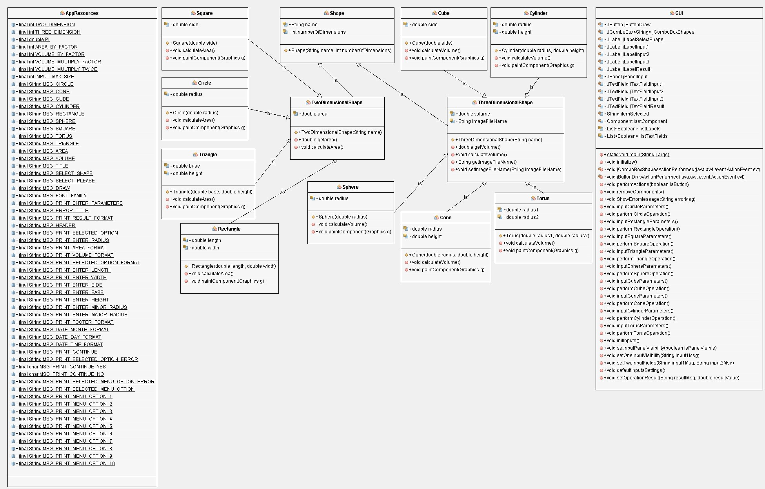

**Test**

**C**

**ases**

|  |  |
| --- | --- |
| **Test Case #1: Construct and Draw a Circle** | |
| **Description** | To construct and draw a circle and print area of the circle |
| **Input** | Radius of circle = 80 |
| **Expected Result** | The area of the Circle is 20096.00 |
| **Actual Result** | The area of the Circle is 20096.00 |
| **Pass** | **Yes** |
| **Screenshot** |  |
|  | |

|  |  |
| --- | --- |
| **Test Case #2: Construct and Draw a Rectangle** | |
| **Description** | To construct and draw a Rectangle and print area of the Rectangle |
| **Input** | Length = 300  Width = 100 |
| **Expected Result** | The area of the Rectangle is 30000.00 |
| **Actual Result** | The area of the Rectangle is 30000.00 |
| **Pass** | **Yes** |
| **Screenshot** |  |

|  |  |
| --- | --- |
| **Test Case #3: Construct and Draw a Square** | |
| **Description** | To construct and draw a Square and print area of the Square |
| **Input** | Side = 200 |
| **Expected Result** | The area of the Square is 40000.00 |
| **Actual Result** | The area of the Square is 40000.00 |
| **Pass** | **Yes** |
| **Screenshot** |  |

|  |  |
| --- | --- |
| **Test Case #4: Construct and Draw a Triangle** | |
| **Description** | To construct and draw a Triangle and print area of the Triangle |
| **Input** | Height = 300  Base = 100 |
| **Expected Result** | The area of the Triangle is 15000.00 |
| **Actual Result** | The area of the Triangle is 15000.00 |
| **Pass** | **Yes** |
| **Screenshot** |  |
|  | |

|  |  |
| --- | --- |
| **Test Case #5: Construct and Draw a Sphere** | |
| **Description** | To construct and draw a Sphere and print volume of the Sphere |
| **Input** | Radius = 100 |
| **Expected Result** | The volume of the Sphere is 3140000.00 |
| **Actual Result** | The volume of the Sphere is 3140000.00 |
| **Pass** | **Yes** |
| **Screenshot** |  |

|  |  |
| --- | --- |
| **Test Case #6: Construct and Draw a Cube** | |
| **Description** | To construct and draw a Cube and print volume of the Cube |
| **Input** | Side = 120 |
| **Expected Result** | The volume of the Cube is 1728000.00 |
| **Actual Result** | The volume of the Cube is 1728000.00 |
| **Pass** | **Yes** |
| **Screenshot** |  |
|  | |

|  |  |
| --- | --- |
| **Test Case #7: Construct and Draw a Cone** | |
| **Description** | To construct and draw a Cone and print volume of the Cone |
| **Input** | Radius = 120  Height = 100 |
| **Expected Result** | The volume of the Cone is 1507200.00 |
| **Actual Result** | The volume of the Cone is 1507200.00 |
| **Pass** | **Yes** |
| **Screenshot** |  |

|  |  |
| --- | --- |
| **Test Case #8: Construct and Draw a Cylinder** | |
| **Description** | To construct and draw a Cylinder and print volume of the Cylinder |
| **Input** | Radius = 120  Height = 100 |
| **Expected Result** | The volume of the Cylinder is 4521600.00 |
| **Actual Result** | The volume of the Cylinder is 4521600.00 |
| **Pass** | **Yes** |
| **Screenshot** |  |

|  |  |
| --- | --- |
| **Test Case #9: Construct and Draw a Torus** | |
| **Description** | To construct and draw a Torus Sphere and print volume of the Torus |
| **Input** | Minor Radius = 120  Major Radius = 100 |
| **Expected Result** | The volume of the Torus is 28395648.00 |
| **Actual Result** | The volume of the Torus is 28395648.00 |
| **Pass** | **Yes** |
| **Screenshot** |  |
|  | |

|  |  |
| --- | --- |
| **Test Case #10: Empty Input – Error Handling** | |
| **Description** | To handle error message for empty input |
| **Input** | Blank Input text field |
| **Expected Result** | Print error message |
| **Actual Result** | Error – Empty String |
| **Pass** | **Yes** |
| **Screenshot** |  |
|  | |

|  |  |
| --- | --- |
| **Test Case #11: Input Should be a Positive value – Error Handling** | |
| **Description** | To handle error message for positive input value |
| **Input** | Negative Input text field such as -9 |
| **Expected Result** | Print error message |
| **Actual Result** | Error Message – Input Should be a Positive value |
| **Pass** | **Yes** |
| **Screenshot** |  |
|  | |

|  |  |
| --- | --- |
| **Setup and Run Application** | |
|  |  |

1. Download the project zip file
2. Open the NetBeans IDE
3. Under File menu option, Select Import Project from ZIP
4. Choose the project zip file location from file chooser dialog box and click import button
5. Project will be imported in NetBeans
6. Compile the project
7. Run the project

## Lesson Learned

During the design and implementaion of this project, I have learned a lots of new things about the GUI and Object Oriented

Programming Languages. Here are few implmetation done in this projects

* Coded all the classes in Java with advanced concepts of OOPs
* Java Swing library is used for the GUI implementation
* Learned s Swing AWT components including Layout Managers, Event Handlers, Listener Interfaces, Adapter Classes,

Inner Classes, Buttons and other widgets GUI components, mouse events, button events

* Application resources are maintained in as share class
* Inheritence and polymorphism concepts are used with the help of extends, super and override keywords
* Project is written in resuseable code manner
* A modular approach of coding is used for the implementation of the classes
* Error and Exception handling is properly implemented